MISSING DOG
PLEASE DO NOT CALL OR CHASE
123-456-7890
CALL OR TEXT WITH ANY INFORMATION

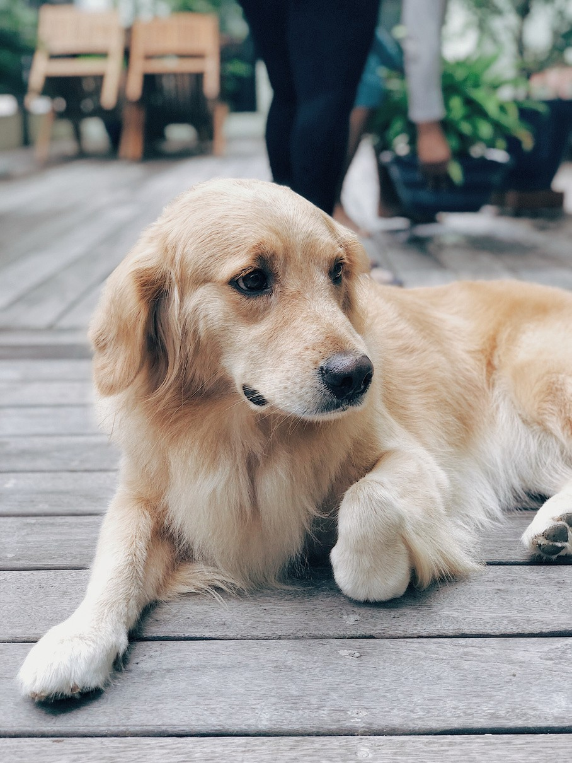
GUILLERMO
Breed: Labrador Color: Golden brown Collar: Yellow

Guillermo has been missing since 4 January 2030 and was last seen at Grise Fiord Park.

REWARD
$200

