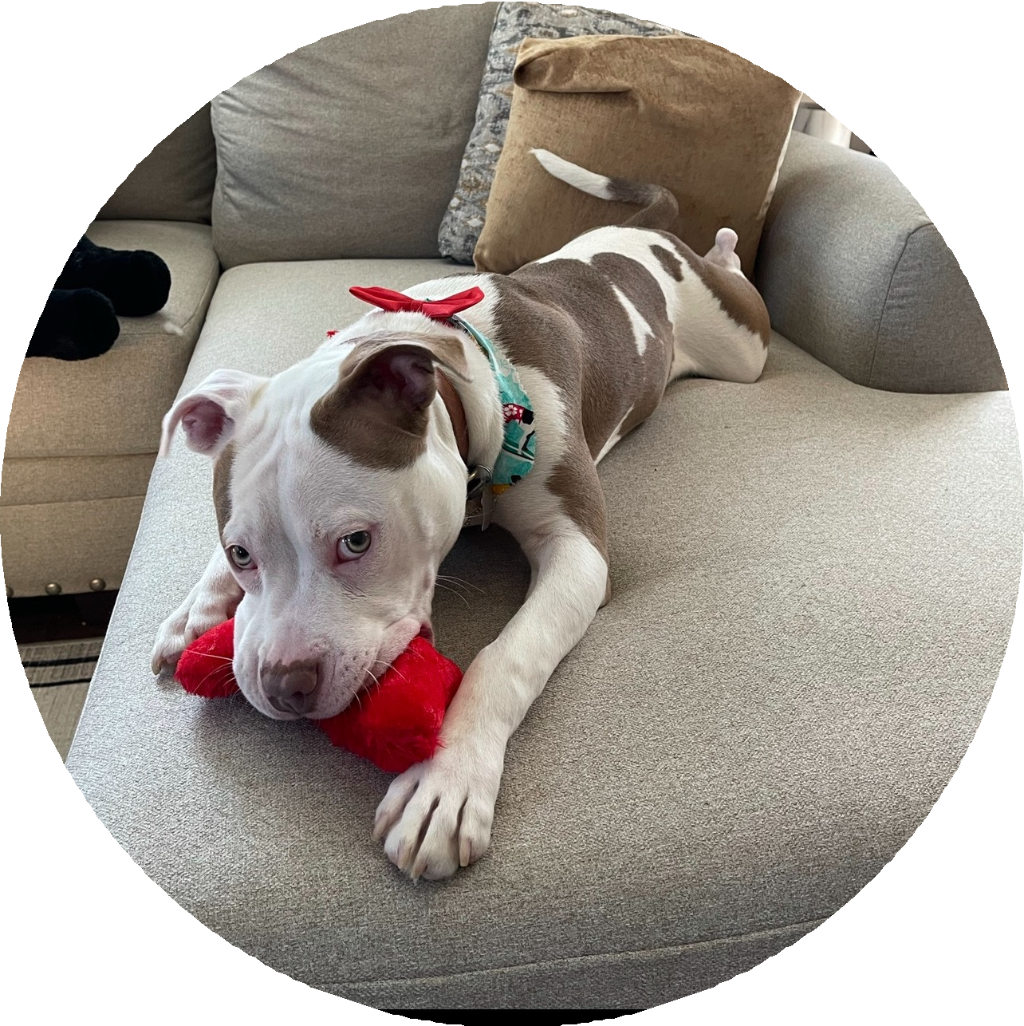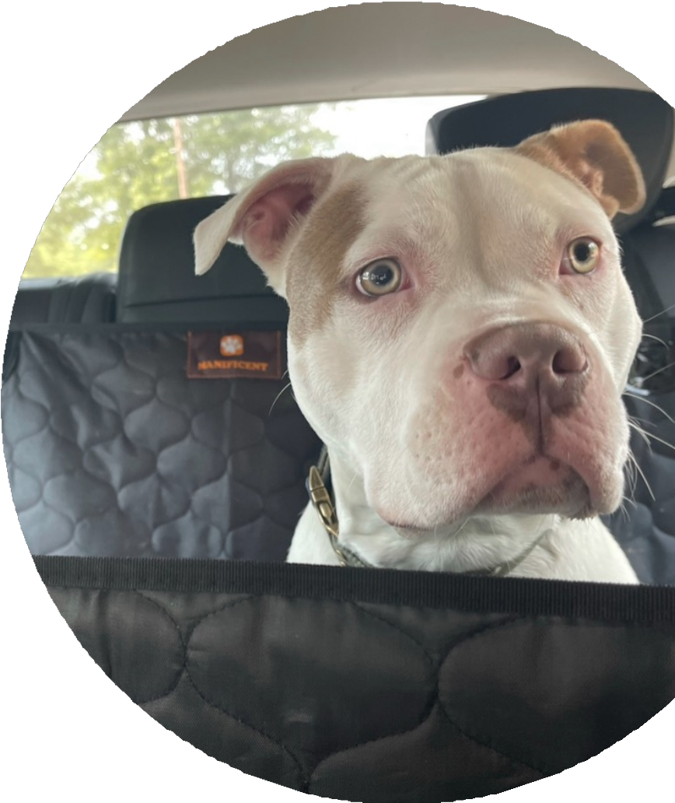NAME
Age Sex Breed Weight
Spayed/Neuter ed/Intact?
Potty trained? Crate trained? Energy level Their personality, things they like, don't like How are they with dogs/cats/kids/ strangers?

We are looking to rehome him/her because...

PLEASE CONTACT US IF YOU ARE ABLE TO ADOPT (NAME)
CONTACT INFO

